# **One Page Style-Guide**

## **Sizing/Margins/Padding**

* Relative units (rem) used to establish responsive design
* Font/element sizing will be fractional of rem units (1 rem = 16px)
* Maintain appropriate margins and padding between items (0.5 rem min)

## **Display Font**

Audiowide - regular

**Audiowide - bold**

## **Body Font**

Roboto - regular

**Roboto - bold**

# 

## **Logo**



## **Favicon**

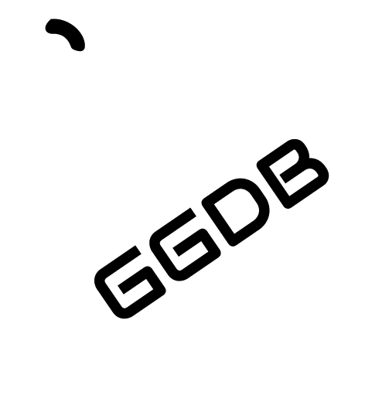

## **Sprite**



## **Colour Palette**

|  |  |  |  |  |  |
| --- | --- | --- | --- | --- | --- |
| **#1b03a3** | **#213586** | **#27686a** | **#2d9a4d** | **#33cd31** | **#39ff14** |